# 

**CASA composition of BFIs**

*As of 11-month data for FY 2081/82*



Prepared By:

Research Department

Sanima Capital Limited

*sanimacapital@sanimabank.com*

# Eleven months of the Current Fiscal Year 2081/82, ending in Jestha

Nepal Rastra Bank has recently released statistics detailing the financial performance of commercial banks for the initial eleven months of the current fiscal Year 2081/82, ending in Jestha

# Deposit vs Credit

|  |  |  |  |  |  |
| --- | --- | --- | --- | --- | --- |
|  | | Class "A" | Class "B" | Class "C" | Overall |
| 1. Credit, Deposit Ratios (%) | | | | | |
| 1 | Total Deposit/GDP | 102.56 | 10.05 | 2.08 | 114.69 |
| 2 | Total Credit/GDP | 80.97 | 8.52 | 1.67 | 91.15 |
| 3 | Total Credit/ Total Deposit** | 78.94 | 84.80 | 80.15 | 79.48 |
| 4 | CD Ratio* | 77.78 | 84.47 | 79.64 | 78.39 |
| 5 | Fixed Deposit/Total Deposit | 49.49 | 51.51 | 66.48 | 49.98 |
| 6 | Saving Deposit/Total Deposit | 36.07 | 38.48 | 23.99 | 36.06 |
| 7 | Current Deposit/Total Deposit | 6.20 | 2.16 | 1.11 | 5.75 |
| 8 | Call Deposit/Total Deposit | 7.43 | 7.72 | 8.36 | 7.47 |
| 9 | NPL/ Total Loan^ | 5.05 | 5.56 | 13.04 | 5.24 |
| 10 | Total LLP/Total Loan | 5.21 | 5.31 | 11.55 | 5.34 |
| 11 | Deprived Sector Loan/Total Loan $^ | 5.60 | 7.12 | 5.47 | 5.74 |
| 1. Liquidity Ratios (%) | | | | | |
| 1 | Cash & Bank Balance/Total Deposit | 7.59 | 6.16 | 6.91 | 7.45 |
| 2 | Investment in Gov. Securities/Total Deposit | 16.66 | 14.05 | 11.71 | 16.34 |
| 3 | Total Liquid Assets/Total Deposit | 25.01 | 22.10 | 23.86 | 24.74 |
| 1. Capital Adequacy Ratios (%) | |  |  |  |  |
| 1 | Core Capital/RWA | 9.50 | 10.27 | 10.55 | 9.58 |
| 2 | Total Capital/RWA | 12.34 | 12.97 | 12.51 | 12.40 |

* Class A institutions represent the largest, most established segment with dominant market share, strong digital presence, and reasonable asset quality
* Class B institutions show balanced performance with the strongest lending efficiency and capital position
* Class C institutions are much smaller players with concerning asset quality metrics, limited digital presence, but relatively good liquidity

The data suggests a three-tier banking system with Class A serving as major national institutions, Class B as mid-sized banks, and Class C as smaller regional players, possibly operating in higher-risk market segments.

**NPL of Banks**

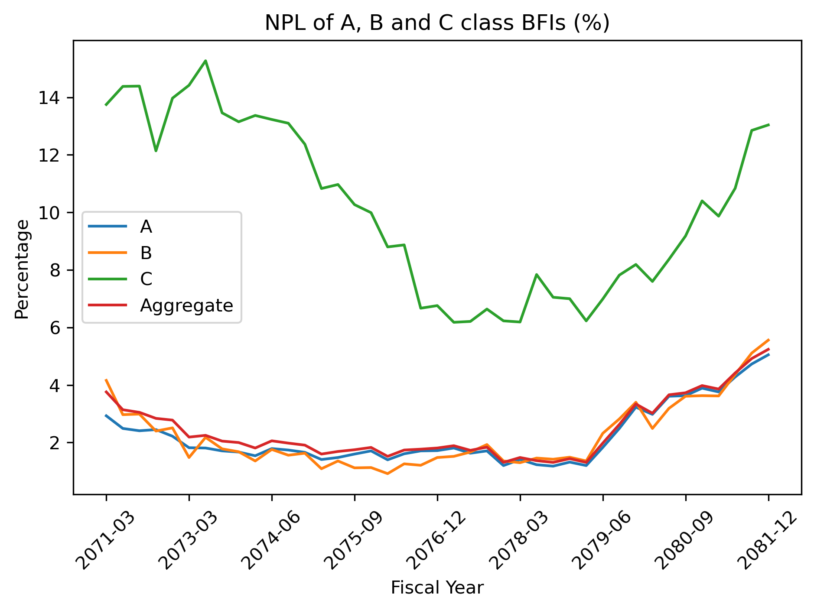

**Box Plot Analysis of NPL**

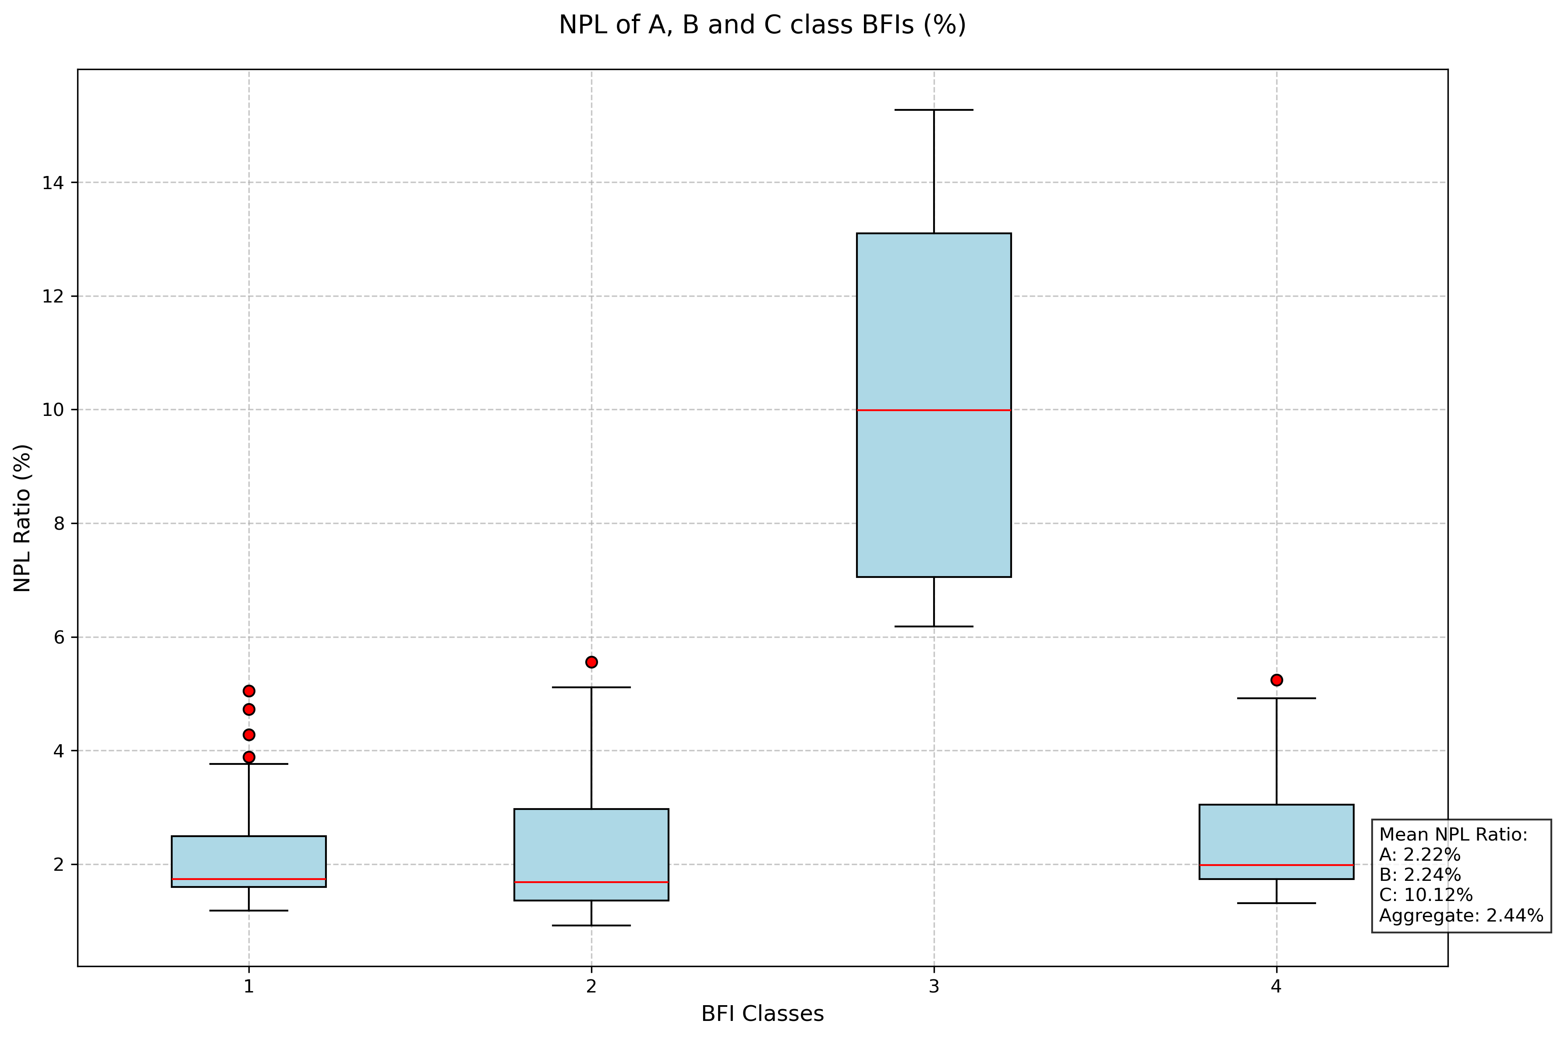

This box plot visualization shows the distribution of Non-Performing Loan (NPL) ratios across different classes of Banks and Financial Institutions (BFIs). Class C institutions face significantly greater challenges in managing their loan portfolios and may require more focused attention to improve their asset quality

Improving asset quality is crucial, particularly given the varying NPL ratios across bank classes (ranging from 5.05% in Class A 5.56% in Class B to 13.04% in Class C banks). Financial Institution with higher NPL ratios, especially Class C institutions, may need to prioritize asset quality improvement before pursuing aggressive credit growth

**Interest Rate**

|  |  |  |  |  |
| --- | --- | --- | --- | --- |
| Interest Rate | 2023/24 | 2024/25 | 2023/24 | 2024/25 |
| May-Jun | May-Jun | May-Jun | May-Jun |
| Jestha | Jestha | Jestha | Jestha |
| Deposit rates | Rates | | Weights | |
| Saving | 3.77% | 3.38% | 29.79% | 36.72% |
| Fixed: | 8.38% | 5.92% | 57.65% | 49.56% |
| 3-6 months | 6.75% | 4.28% | 13.34% | 12.04% |
| 6-12 months | 7.38% | 4.54% | 15.40% | 17.03% |
| 1-2 yrs | 8.95% | 5.64% | 14.48% | 8.30% |
| 2 yrs and above | 10.37% | 9.66% | 14.43% | 12.18% |
| Call | 1.66% | 1.12% | 6.54% | 7.13% |
| Certificate of Deposits | 0.00% | 0.00% | 0.00% | 0.00% |
| Other | 1.22% | 2.22% | 0.04% | 0.03% |
| Non interest bearing deposits | 0.00% | 0.00% | 5.99% | 6.55% |
| Current | 0.00% | 0.00% | 5.32% | 5.83% |
| Margin | 0.00% | 0.00% | 0.66% | 0.70% |
| Other NIB | 0.00% | 0.00% | 0.01% | 0.02% |
| Aggregate Deposits | 6.06% | 4.29% | 100.00% | 100.00% |

This table compares deposit interest rates and their corresponding weights (share in the deposit mix) between two periods: May-june of fiscal year 2023/24 to May-june of 2024/25. The data covers various deposit categories—savings, fixed deposits of varying maturities, call deposits, certificate of deposits, and non-interest-bearing deposits. This broad reduction in deposit rates suggests an easing interest rate environment of deposit products by financial institutions.

More funds have moved into lower-yielding, shorter-term deposits (like savings and call accounts), while the share of traditionally higher-rate fixed deposits has decreased. All deposit categories witnessed downward rate adjustments, indicating a coordinated response to macroeconomic conditions. The most pronounced reductions occurred in

* Fixed deposits (1-2 years): Dropped from 8.95% to 5.64% (-331 basis points)
* Fixed deposits (6-12 months): Declined from 7.38% to 4.54% (-284 basis points)
* Savings accounts: Decreased from 3.77% to 3.38% (-39 basis points)

The data reveals a flattening of the yield curve across deposit maturities. Previously, longer-term deposits commanded significantly higher premiums, but this differential has narrowed considerably, suggesting reduced incentives for long-term savings commitments.

**CASA Compotion of Commercial Banks**

|  |  |  |  |  |  |
| --- | --- | --- | --- | --- | --- |
| Company Name | Current Deposits | Savings Deposits | Fixed Deposits | Call Deposits | Others Deposits |
| RBB | 8.22% | 48.34% | 37.13% | 6.00% | 0.31% |
| NBL | 7.48% | 46.68% | 36.99% | 7.89% | 0.95% |
| MBL | 5.31% | 45.34% | **41.65%** | 6.56% | 1.14% |
| SCB | 19.82% | 44.09% | 24.19% | 10.46% | 1.44% |
| LSL | 4.45% | 41.32% | **45.49%** | 7.78% | 0.96% |
| NICA | 3.42% | 37.59% | 52.15% | 6.77% | 0.07% |
| GBIME | 6.13% | 37.05% | 49.38% | 6.71% | 0.73% |
| PRVU | 4.64% | 36.55% | 51.87% | 6.06% | 0.88% |
| SBL | 6.21% | 36.52% | 47.03% | 9.54% | 0.71% |
| NABIL | 8.61% | 36.03% | 45.99% | 8.59% | 0.77% |
| NMB | 5.15% | 35.59% | 49.74% | 8.41% | 1.11% |
| SANIMA | 5.94% | 35.57% | **50.25%** | 7.47% | 0.78% |
| ADBL | 6.32% | 34.22% | **54.57%** | 4.48% | 0.41% |
| CZBIL | 4.21% | 33.83% | **53.76%** | 7.59% | 0.61% |
| KBL | 4.89% | 31.02% | **54.20%** | 9.24% | 0.65% |
| SBI | 5.44% | 30.80% | **55.44%** | 7.15% | 1.17% |
| HBL | 5.65% | 30.75% | 55.52% | 6.78% | 1.29% |
| EBL | 6.33% | 29.07% | 59.15% | 4.47% | 0.98% |
| NIMB | 6.35% | 28.36% | 54.36% | 10.00% | 0.93% |
| PCBL | 3.11% | 21.27% | **67.91%** | 6.59% | 1.12% |
| Overall Banking industry | 6.2% | 36.1% | 49.5% | 7.4% | 0.8% |

The table compares the deposit composition across various banks in terms of the proportion of Current, Savings, Fixed, Call, and Other deposits, culminating in an industry-wide average. Each bank displays a unique deposit mix, reflecting its strategic focus, target customer segments, and liquidity management approaches.

On average, the banking industry holds about 49.5%of its deposits in fixed term accounts: Savings deposits constitute the second-largest share at around 36.1%.

Banks heavily reliant on high-interest fixed deposits (FDs) might feel cost pressure if they are locked into longer-term deposits at previously higher rates. They have less flexibility to quickly adjust their cost of funds downward. Institutions that rely more on lower-cost deposits (such as current and savings accounts) can adapt more easily, reducing overall interest expenses as rates fall. Banks with a large share of low-cost, liquid deposits benefit from immediate cost savings and can more easily maintain profitability. Those reliant on high-cost fixed deposits may face short-term margin pressure.

During periods of excess liquidity, the deposit composition strongly influences how well a bank can adjust to falling interest rates. Over time, the shift in the interest rate environment encourages re-balancing towards more flexible, low-cost deposit structures, improving resilience and competitiveness in both excess and normal liquidity scenarios.

|  |  |  |  |  |  |  |  |  |
| --- | --- | --- | --- | --- | --- | --- | --- | --- |
| Company Name | Paid Up Capital | Net Profit | EPS(D) as of Q3 | PE(D) as of Q3 | Last Close as of 2025-Jul-15 | Net Profit 11 Month 2024/25May-Jun | Eps 11 months | Pe 11 months |
| NICA | 14,917,567 | 156,776 | 1.40 | 289.0 | 404.6 | 829,736 | 6.07 | 66.68 |
| LSL | 24,346,512 | 1,652,162 | 9.05 | 25.1 | 226.9 | 2,579,201 | 11.56 | 19.63 |
| CZBIL | 14,769,013 | 961,894 | 8.68 | 25.3 | 219.6 | 1,411,425 | 10.43 | 21.06 |
| MBL | 11,621,357 | 1,102,628 | 12.65 | 19.2 | 242.6 | 1,509,249 | 14.17 | 17.13 |
| HBL | 21,656,616 | 500,048 | 3.08 | 74.2 | 228.6 | 905,391 | 4.56 | 50.12 |
| GBIME | 38,115,853 | 4,534,098 | 15.86 | 15.9 | 252.9 | 6,036,419 | 17.28 | 14.64 |
| SBL | 14,089,980 | 1,668,260 | 15.79 | 22.7 | 357.7 | 2,218,127 | 17.17 | 20.83 |
| SANIMA | 13,581,526 | 1,652,477 | 16.22 | 22.0 | 356.3 | 2,155,695 | 17.32 | 20.58 |
| PCBL | 19,402,576 | 2,229,304 | 15.32 | 17.5 | 267.9 | 2,905,003 | 16.33 | 16.40 |
| NABIL | 27,056,998 | 5,051,420 | 24.89 | 21.0 | 522.2 | 6,408,329 | 25.84 | 20.21 |
| SBI | 10,899,158 | 1,203,261 | 14.72 | 29.2 | 430.0 | 1,549,245 | 15.51 | 27.73 |
| NMB | 18,366,706 | 2,373,287 | 17.23 | 15.1 | 260.3 | 3,031,117 | 18.00 | 14.46 |
| SCB | 10,042,368 | 2,173,777 | 28.86 | 22.7 | 655.1 | 2,726,195 | 29.61 | 22.12 |
| NIMB | 34,128,595 | 4,540,004 | 17.74 | 12.6 | 223.7 | 5,688,175 | 18.18 | 12.30 |
| EBL | 12,944,694 | 3,457,635 | 35.61 | 19.4 | 689.7 | 4,240,676 | 35.74 | 19.30 |
| KBL | 26,225,861 | 285,823 | 1.45 | 147.9 | 214.4 | 371,081 | 1.54 | 138.89 |
| PRVU | 23,542,490 | 1,876,060 | 10.63 | 20.4 | 216.8 | 2,311,997 | 10.71 | 20.24 |
| ADBL | 13,855,224 | 1,844,360 | 15.40 | 20.5 | 315.7 | 1,819,358 | 14.32 | 22.04 |
| NBL | 14,694,023 | 2,783,495 | 25.26 | 11.0 | 279.0 | 3,070,582 | 22.80 | 12.24 |

The table presents data of banks along with their financial metrics at two points in time: after Q3 of a given fiscal year, and after 11 months (May-Jun 2024/25). Key indicators include Paid-Up Capital, Net Profit, Earnings Per Share (EPS), Price-to-Earnings ratio (P/E),

The 11-month performance trends reinforce the sector's overall health, with EBL maintaining its leadership position with 35.74 EPS over the period, followed by SCB (29.61) and NABIL (25.84), demonstrating consistent earning power. NABIL leads in absolute profitability with Rs 6.48billion in net profit, followed closely by GBIME (Rs 6.0 billion) and NIMB (Rs 5.68 billion)

Based on the financial data of these banking institutions, the top 3 have average pe ratio of 15.72 which is siginfianlty lower

**Month on Month NII (in Bill.) Compration of Commerical banks**

|  |  |  |  |  |  |  |
| --- | --- | --- | --- | --- | --- | --- |
| NII | 2081/82 Jestha | 2081/82 Baisakh | 2081/82 Chaitra | 2081/82 Falgun | 2081/82 Magh | 2081/82 Poush |
| KBL | 0.65 | 0.97 | 0.43 | 1.02 | 1.22 | 0.29 |
| GBIME | 1.46 | 1.49 | 1.19 | 1.40 | 1.43 | 1.47 |
| SBL | 0.77 | 0.75 | 0.78 | 0.71 | 0.72 | 0.66 |
| PCBL | 0.78 | 0.78 | 0.83 | 0.73 | 0.68 | 0.69 |
| CZBIL | 0.55 | 0.50 | 0.54 | 0.56 | 0.57 | 0.52 |
| NMB | 0.76 | 0.75 | 0.78 | 0.71 | 0.75 | 0.87 |
| NBL | 0.81 | 0.90 | 0.74 | 0.78 | 0.96 | 0.52 |
| NIMB | 1.10 | 1.12 | 0.61 | 1.13 | 1.21 | 1.40 |
| MBL | 0.46 | 0.38 | 0.59 | 0.45 | 0.39 | 0.62 |
| SANIMA | 0.51 | 0.44 | 0.53 | 0.46 | 0.41 | 0.55 |
| PRVU | 0.80 | 0.53 | (0.02) | 1.17 | 1.07 | 0.35 |
| LSL | 0.91 | 0.91 | 0.92 | 0.88 | 0.91 | 0.81 |
| NICA | 0.83 | 0.88 | 0.82 | 0.85 | 0.94 | 0.78 |
| SCB | 0.39 | 0.35 | 0.36 | 0.33 | 0.37 | 0.25 |
| SBI | 0.44 | 0.45 | 0.43 | 0.43 | 0.42 | 0.16 |
| HBL | 0.79 | 0.79 | 1.04 | 0.75 | 0.73 | 1.12 |
| ADBL | 0.27 | 0.18 | 2.01 | 0.16 | 0.08 | 2.04 |
| EBL | 0.77 | 0.80 | 0.80 | 0.72 | 0.91 | 0.69 |
| NABIL | 1.26 | 1.10 | 1.82 | 1.18 | 1.19 | 1.08 |
| RBB | 0.91 | 0.94 | 0.98 | 0.85 | 0.86 | 0.65 |

The commercial banking sector's lending performance over the 11-month period reveals a mixed landscape with notable variations in loan growth trajectories across institutions. Of 19 banks only three has negative growth PRVU (-0. 11%) , KBL(-1.97%) nad NICA(-15.55%). EBL , NMB , RBB, PCBL, NBL has postive loan growth of of more than 15%.

Based on the comprehensive 11-month performance data across profitability, market valuation, and lending growth metrics, EBL emerges as the standout overall performer in the banking sector NABIL and GBIME represent strong secondary performers with complementary strengths. NABIL excels in absolute profitability with Rs 5.05 billion net profit, maintains substantial lending volumes at Rs 426.75 billion, and demonstrates solid market positioning with reasonable PE ratios, making it a well-rounded institutional performer. GBIME shows the most aggressive lending expansion to Rs 441.82 billion while generating Rs 4.53 billion in profits, though its market valuation suggests some undervaluation relative to performance.

**Development Bank Data over 11 Months**

|  |  |  |  |  |  |  |  |  |
| --- | --- | --- | --- | --- | --- | --- | --- | --- |
| Company Name | Paid Up Capital | Net Profit | EPS(D) as of Q3 | PE(D) as of Q3 | Last Close as of 2025-Jul-15 | Net Profit2024/25 May-Jun | Eps 11 months | PE 11 months |
| LBBL | 3,623,678 | 49,784 | 1.8 | 244.5 | 447 | 217,320.31 | 6.54 | 68.38 |
| MNBBL | 7,046,938 | 724,851 | 13.7 | 28.5 | 390 | 1,051,724.90 | 16.28 | 23.96 |
| SHINE | 4,875,702 | 514,014 | 14.1 | 29.6 | 416 | 738,796.08 | 16.53 | 25.15 |
| GBBL | 5,680,518 | 733,491 | 17.2 | 23.6 | 407 | 1,016,832.35 | 19.53 | 20.85 |
| KSBBL | 3,510,846 | 493,185 | 18.7 | 25.7 | 481 | 669,344.07 | 20.80 | 23.11 |
| JBBL | 4,395,786 | 306,612 | 9.3 | 36.1 | 336 | 436,441.46 | 10.83 | 31.01 |
| SADBL | 3,556,257 | 434,218 | 16.3 | 26.6 | 433 | 562,931.14 | 17.27 | 25.07 |
| GRDBL | 538,722 | 21,285 | 5.0 | 268.5 | 1,337 | 27,509.88 | 5.57 | 240.04 |
| MDB | 1,217,100 | 92,456 | 10.1 | 60.8 | 616 | 113,516.50 | 10.17 | 60.52 |
| MLBL | 4,296,458 | 436,559 | 13.6 | 28.9 | 391 | 534,411.01 | 13.57 | 28.84 |
| CORBL | 525,000 | 17,782 | 4.5 | 500.7 | 2,263 | 19,547.01 | 4.06 | 557.15 |
| SINDU | 557,456 | 78,451 | 18.8 | 45.3 | 850 | 80,618.74 | 15.78 | 53.85 |
| EDBL | 1,249,695 | -6,383 | (0.7) | (880.3) | 599 | (71,332.07) | (6.23) | (96.13) |
| NABBC | 262,468 | -12,675 | (6.4) | (263.9) | 1,699 | (70,536.00) | (29.32) | (57.97) |

This table presents a set of financial institutions of development banks with their Q3 financial metrics and updated figures after Eleven months (May-Jun 2024/25). The data includes Paid-Up Capital, Net Profit, EPS (Earnings Per Share), and P/E (Price-to-Earnings) ratios, as well as the stock’s last closing price.

The development bank sector shows significant performance variation, KSBBL leads the sector with an impressive 20.80 EPS, demonstrating exceptional operational efficiency and profitability generation. GBBL follows closely at 19.53, while SADBL (17.27), SHINE (16.53), MNBBL (16.28), and SINDU (15.78) form a strong cluster of high-performing institutions.

In contrast, several banks are experiencing concerning financial challenges. EDBL (-6.23) and NABBC (-29.32) represent the sector's most critical challenges.

|  |  |  |  |  |  |
| --- | --- | --- | --- | --- | --- |
| Company Name | Current Deposits | Savings Deposits | Fixed Deposits | Call Deposits | Others Deposits |
| EDBL | 2.7% | 42.0% | 40.2% | 15.1% | 0.1% |
| MDB | 4.2% | 37.2% | 53.4% | 5.2% | 0.0% |
| SINDU | 2.2% | 30.0% | 56.5% | 11.3% | 0.0% |
| MLBL | 2.6% | 44.2% | 45.4% | 6.9% | 0.9% |
| SHINE | 1.6% | 42.0% | 51.7% | 4.7% | 0.0% |
| MNBBL | 2.4% | 37.0% | 53.8% | 6.8% | 0.1% |
| GBBL | 1.6% | 42.8% | 46.4% | 9.2% | 0.0% |
| JBBL | 2.6% | 48.3% | 39.8% | 9.2% | 0.1% |
| KSBBL | 2.2% | 32.1% | 58.8% | 6.8% | 0.0% |
| SADBL | 1.6% | 32.7% | 57.3% | 8.4% | 0.0% |
| LBBL | 1.8% | 30.4% | 60.4% | 7.3% | 0.0% |

Based on the CASA (Current Account Savings Account) analysis data for the development banks, several meaningful deposit composition patterns emerge:

SINDU Bank maintains the highest concentration of fixed deposits at 56.5%, with minimal current deposits (2.2%) and relatively low savings deposits (30.0%). This funding structure suggests a heavier reliance on higher-cost, term deposits, which could pressure interest margins but provides greater funding stability. Their high call deposit percentage (11.3%) is also notable, being the highest among all banks listed.

JBBL leads with the highest CASA ratio at 50.9% (2.6% current + 48.3% savings), followed by MLBL at 46.8% (2.6% current + 44.2% savings) and GBBL at 44.4% (1.6% current + 42.8% savings). These institutions demonstrate superior deposit mix management, securing lower-cost funding sources that directly enhance net interest margins and profitability.

The majority of banks show alarming reliance on expensive fixed deposits, with LBBL leading at 60.4%, followed by KSBBL (58.8%), SADBL (57.3%), and SINDU (56.5%). This heavy fixed deposit concentration indicates higher funding costs that compress interest margins and reduce overall profitability. MNBBL (53.8%) and MDB (53.4%) also show concerning fixed deposit dependence, suggesting sector-wide challenges in attracting low-cost deposits.

**Monthly NII Movement of Development Banks**

|  |  |  |  |  |  |
| --- | --- | --- | --- | --- | --- |
| NII | 2081/82 Jestha | 2081/82 Baisakh | 2081/82 Chaitra | 2081/82 Falgun | 2081/82 Magh |
| GBBL | 321,460 | 318,544 | 182,022 | 320,323 | 322,812 |
| MNBBL | 395,437 | 396,066 | 397,057 | 369,434 | 339,380 |
| JBBL | 182,892 | 154,002 | 153,430 | 151,002 | 160,552 |
| SHINE | 227,801 | 227,231 | 170,101 | 228,362 | 232,917 |
| MLBL | 174,963 | 26,822 | 210,994 | 158,042 | 110,212 |
| KSBBL | 219,307 | 201,337 | 165,324 | 193,230 | 216,144 |
| SADBL | 175,398 | 171,725 | 168,139 | 170,343 | 172,356 |
| LBBL | 173,514 | 168,554 | 92,274 | 164,025 | 169,252 |
| EDBL | 47,703 | 45,071 | 58,037 | 42,901 | 32,011 |
| MDB | 23,800 | 19,636 | 20,946 | 14,984 | 10,861 |
| SINDU | 22,574 | 2,556 | 20,144 | 9,679 | 8,857 |

In loan growth except JBBL all have increase the deposit growth. GBBL demonstrates the ideal combination with a solid 44.4% CASA ratio and excellent 19.53 EPS, ranking second in profitability. This validates the theoretical relationship between low-cost deposit mobilization and superior earnings generation. KSBBL leads the sector with 20.80 EPS despite having a concerning 58.8% fixed deposit dependency, indicating that operational excellence and asset quality can compensate for suboptimal funding structures.

**Disclaimer:**

* *This report is based on data published by Nepal Rastra Bank (NRB) for the month of Jestha, 2082 and is intended for informational purposes only. Any decision made based on this report are solely at the viewer discretion*